**Name: Seerat Sharma**

**UMID: UMID23042532255**

**Internship: Web Development Intern**

**Project 1 Report: Virtual Art Gallery**

**Project Overview**

The Virtual Art Gallery is an online platform to bring the beauty the classical art into a global level. The website is created to present the collection of famous artworks from three major movements Renaissance, Baroque and Romanticism. This also includes pieces from the 19th to 0th century and thus offering a diverse timeline to understand the history between these fine arts. The idea is to experience the traditional art museum digitally.

**Problem Statement**

There are many museums and galleries that promote this art culture and education, but there are many external factors that make it difficult for art enthusiasm to learn and preserve the history of these arts. There are various factors like geo location, cost or time that makes it difficult for people to explore and learn about it. Thus a large segment of population misses on the opportunity to explore and appreciate the art

**Solution**

To meet these challenges, the Virtual Art Gallery was built, an online platform that provides an enlightening tour of the world's most famous artworks. The site organizes works by broad art movements and displays them in visually pleasing cards with titles, artist names, and dates. This format is engaging since it enables users to engage with content on their own time. With very little learning curve and responsive design, the site welcomes users to dive into the world of art regardless of whether they are on a desktop, tablet, or phone.

**Objective**

The main objective of the Virtual Art Gallery is to increase the accessibility of fine art and make art history an enjoyable experience.

* To make famous artworks and their stories accessible to a global virtual audience.
* To expose users to notable art movements and their place in history.
* To enable self-directed learning with classified content.
* To make it easily accessible on any cross-device platform.
* Fostering greater interest in the arts via an entertaining and visually engaging platform.

**Technologies Implemented**

The gallery has been created using fundamental front-end technologies that enable a seamless and interactive experience:

**HTML5:** Content structuring and semantic clarity.

**CSS:** Lay out the content, implement colour schemes, and make it responsive for different screen sizes.

**JavaScript:** Drives dynamic element like theme switching, modal image views, and filtering based on years.

**Responsive Web Design:** Enables the site to work effectively on different devices, ranging from large screens to mobile phones.

**Future Technology Implementation**

**Firebase/MongoDB**: For storage and maintenance such of user profiles and uploads of new artwork.

**React.js:** To ensure the application can scale and be modular.

**Node.js/Express:** For building backend services for authentication, data handling, and beyond.

**Features**

1. **Homepage Art Display**

* Features paintings by well-known artists worldwide like Vincent van Gogh, Claude Monet, and Salvador Dalí.
* A dropdown menu enables users to filter artworks by year: before 1900, 1900–190, and after 190.

1. **Category Dedicated Pages**

* There is a page for each movement—Renaissance, Baroque, and Romanticism.
* The pages contain short overviews clarifying the dominant characteristics of the movement.
* Features renowned works like The Birth of Venus, Girl with a Pearl Earring, and Wanderer above the Sea of Fog.

1. **Theme Toggle**

* A header button enables users to toggle between light and dark themes.
* Reduces eye strain and personalizes the experience.

1. **Interactive Image Modal**

* Clicking on any painting expands it in a centered modal.
* Provides improved viewing and detail examination without leaving the page.

1. **User-Friendly Navigation**

* Clean and simple layout with intuitive links in header and footer.
* Makes it easy for users to navigate between sections.

1. **Responsive and Accessible Layout**

* Feels great on desktop, tablet, and mobile screens.
* Employs accessible elements for keyboard navigation and screen readers.

**Future Enhancements**

Here are some of the features that can we implemented further to enhance the experience:

1. **Admin Dashboard**

Offer a backend system for uploading new pieces of artwork with descriptions and metadata.

1. **User Accounts**

Include login/signup function to allow users to save favourites, view history, or set preferences.

1. **Search Bar and Advanced Filters**

Enable searching by artist, artwork title, medium, or keyword.

Include more style, country, and period filters.

1. **Multimedia Integration**

Include audio descriptions, virtual guided tours, and video documentaries.

1. **Interactive Community Tools**

Allow features such as comments, likes, and discussion threads.

Create a mini social network for art enthusiasts.

1. **Language Options**

Localize the gallery in multiple languages to expand the global reach.

**Conclusion**

The Virtual Art Gallery is a connection between traditional art and the digital age. By using digital media and offering a careful accessible interface it encourages the people with love of art to access theme remotely. It is built with fundamental web technologies; and thus illustrating how technology and art can meet in the middle to provide accessibility. With the continual development and new additions, it could become an extensive, world-used educational tool.

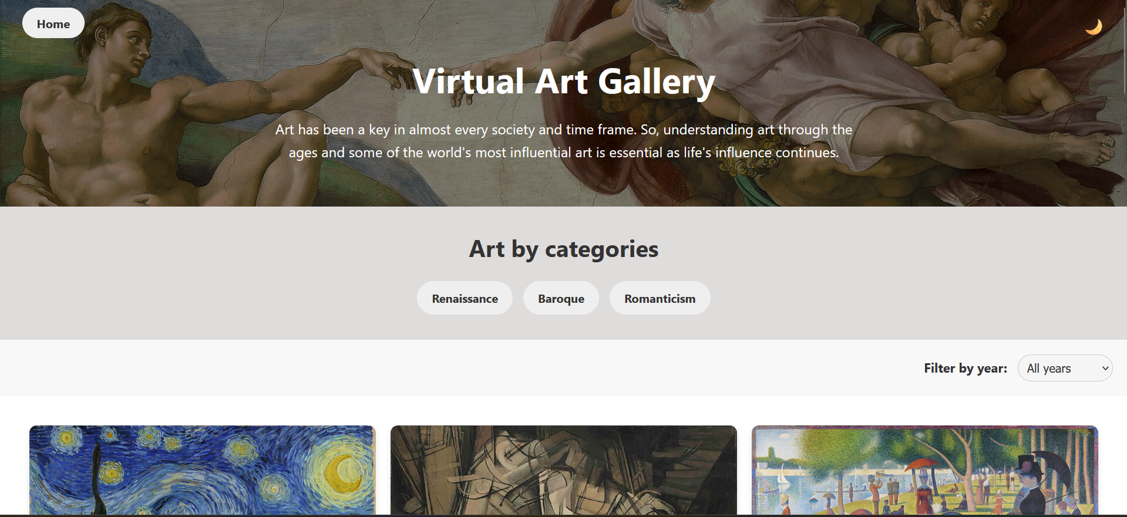

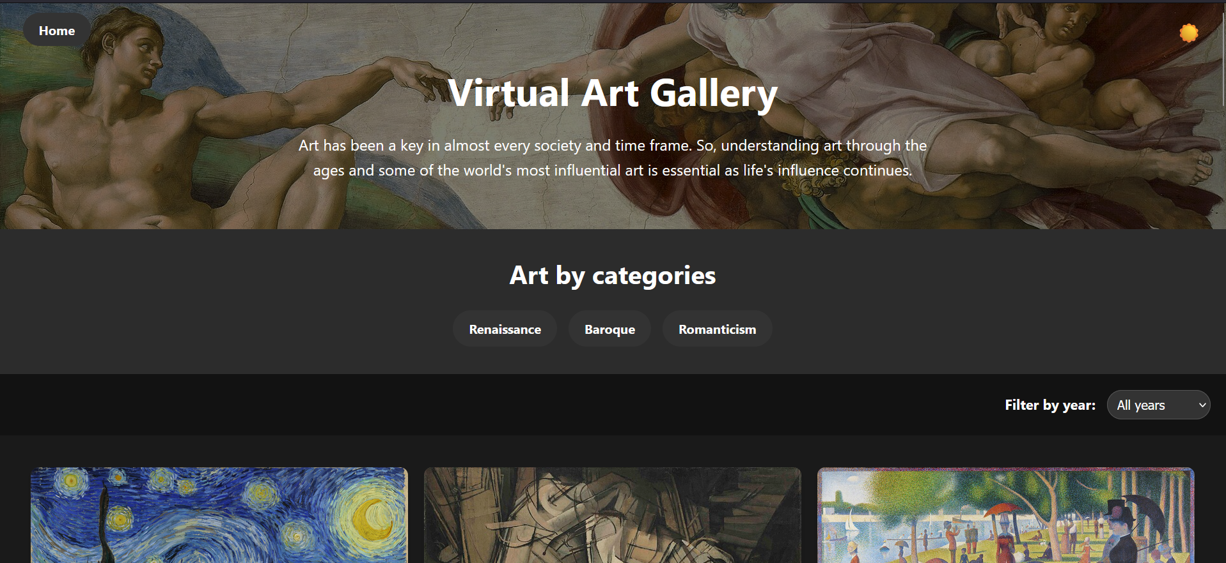

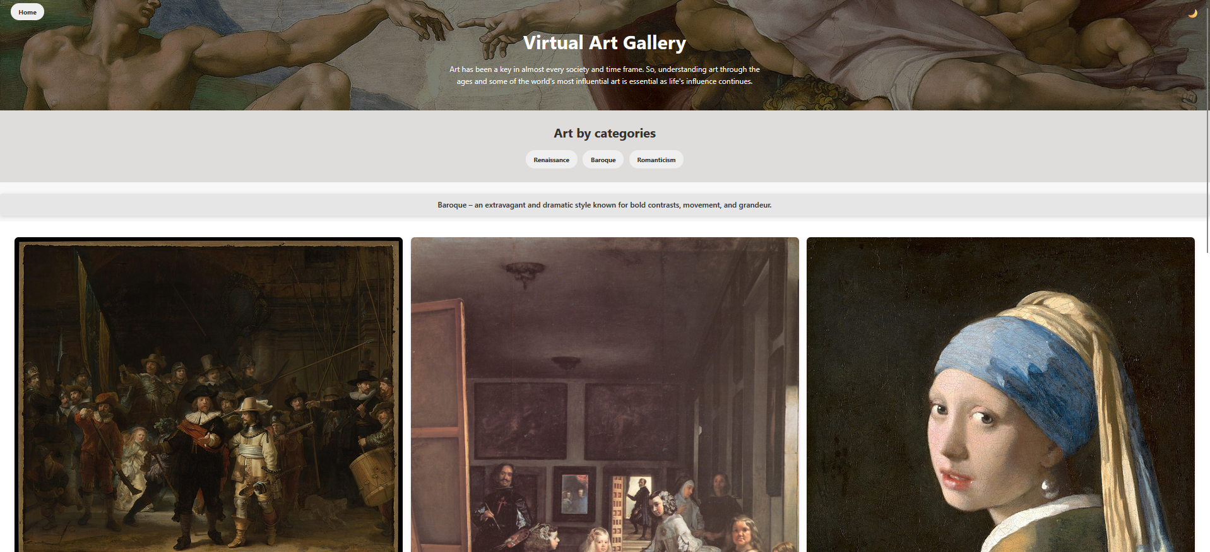

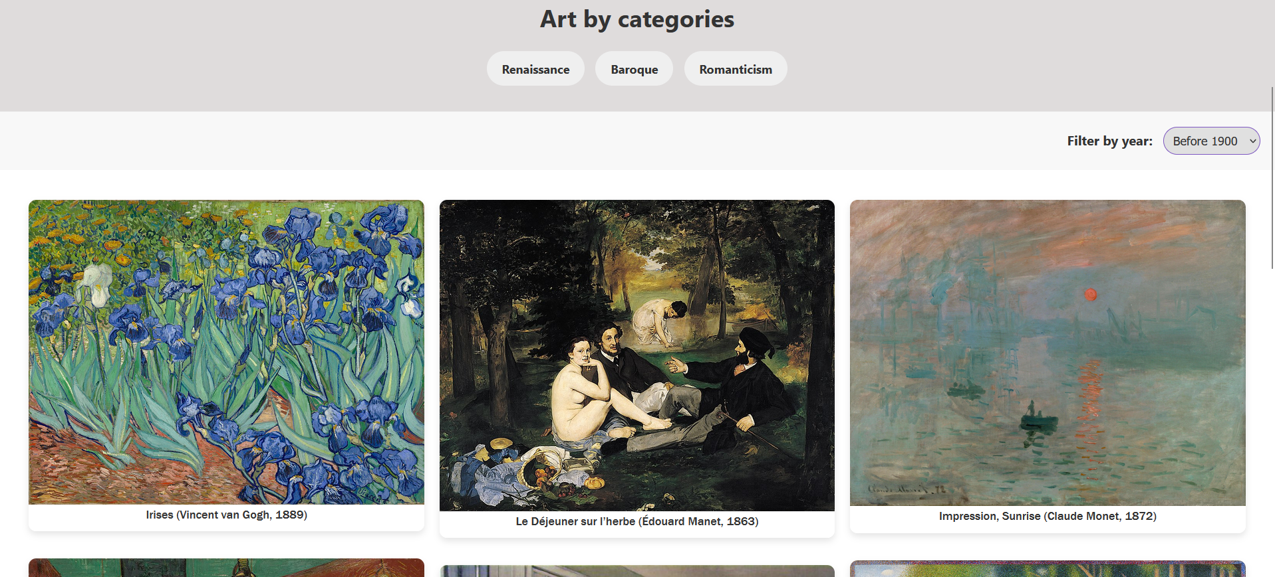

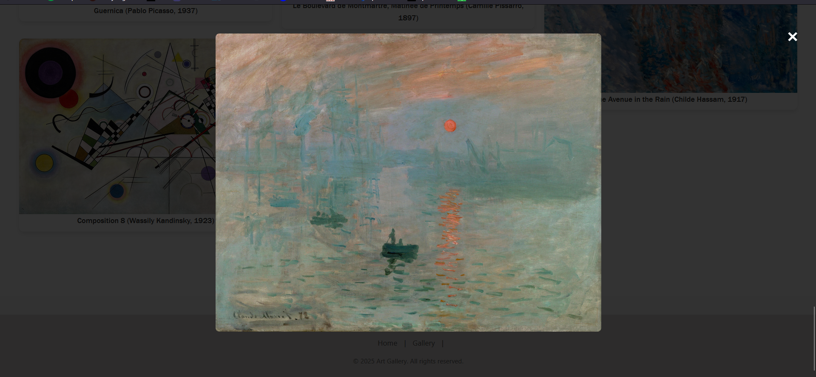

GitHub: <https://github.com/seerat-00/Virtual-Art-Gallery.git>

**Project 2 Report: Cruise Ship Management**

**Project Overview**

The Cruise Ship Management System is a web-application to automate the management of services on a cruise ship. The cruise is one of the largest tourism sectors globally and it requires accuracy in the management of operations that range from ticket booking and catering services to resort bookings and fitness centre membership.

In many cases several departments work in a clustered environment in redundancies, booking clashes, and inefficiency of services. This project offers an integrated, digital solution that implements all the operations on a common platform, providing both passengers and administrators real-time, management of bookings and reservations.

This system can handle bookings for resorts, movies, gyms, spas, party rooms, and catering and thus simulating the luxury of cruise lifestyle while providing processing for administrative positions such as Admin, Voyager (customer), and Manager.

**Problem Statement**

Operating in a cruise ship is a challenge on its own considering the many services being extended to passengers. There are many systems today lead to:

* Double-booking of facilities like resorts and party halls.
* No real-time synchronization of services.
* Inability to monitor seat availability for movie screenings.
* Manual reliance for verifying catering orders or beauty salon appointments.
* Few user-friendly interfaces for customers to book efficiently.

These factors lower customer satisfaction, raise expenses, and thus increasing manual errors.

**3. Objective**

The major objectives of the Cruise Ship Management System is:

* To offer a centralized, user-friendly interface for booking and managing cruise ship services.
* To provide real-time availability and conflict resolution in booking operations.
* To enable passengers (Voyagers) to self-govern their activities.
* To provide admins with control panels for service and data management.
* To minimize errors and overlaps in booking through automated validation.
* To maximize the cruise experience through a seamless digital interface.

**4. Proposed Solution**

Our solution is a web application developed with technologies that’s supports:

* **Role-Based**: Admins, Voyagers, and Managers are assigned to different services.
* **Service Booking**: Vogayers are able to book catering services, resorts, cinema tickets, salons, gyms, and party halls.
* **Availability Check**: Bookings conflicts are checked for by the system prior to confirmation.
* **Firebase Integration**: Firebase is used for real-time data updates, authentication, and Firebase database management.
* **Logging and Alerts**: All major actions are logged, and users are immediately notified of successes or failures.
* **Responsive Design**: The application is viewable on desktop and mobile web browsers.

Through this cruise management is effective, and the passenger has a smooth experience.

**5. Technology Stack**

**Frontend:**

* **React.js**: To develop interactive user interfaces and manage states.
* **CSS3**: Modular and custom styling for elements using .css files.
* **React Icons**: To add visual accessibility and interface clarity.

**Backend:**

* **Firebase Authentication**: For secure user role management, login, and registration.
* **Firebase Firestore**: Cloud-hosted database for storing bookings, user data, and services.
* **Netlify:** For deployment.

**Additional Libraries:**

* **React Router DOM**: For routing and navigation among pages.
* **JavaScript Date and Time Libraries**: For scheduling and resolving time conflicts logic.

**6. Key Features**

1. **Role-Based Services**

* **Admin** can manage all bookings and data.
* **Voyager** (passenger) can book services.
* **Manager** can see analytics or monitor activity.

1. **Resort and Movie Ticket Booking**

* Passengers can book resorts and movies with given time slots.
* The system avoids booking in case of a timing clash or seat unavailability.
* Management conflict the reservations through time comparison logic.

1. **Catering Services**

* Menu items are grouped (e.g., Main Course, Snacks, and Desserts).
* Passengers can add products to their cart and place an order.
* System logs total cost and order in Firestore.

1. **Party Hall Booking**

* Users can book halls depending on availability.
* Conflict of time slot prevents halls from getting double-booked.
* Admin sees all bookings to keep track of hall usage.

1. **Beauty Salon Appointments**

* Time-limited appointment system.
* Tidy interface to look at existing bookings and add new ones.

1. **Fitness Centre Access**

* Reserve gym, spa, or swimming sessions.
* System does not allow duplicate bookings and gives user feedback.

1. **Clear Cart and Order Management**

* Users can cancel single items or clear all bookings.
* All the bookings are time-stamped and saved.

1. **Logging and Error Handling**

* Logging is done for all the major operations (e.g., bookings confirmed, deletions).
* Console logs and user alerts give feedback for debugging and UX.

**7. Booking Flow: Resort and Movie**

1. Voyager logs in and chooses date, start time, and end time.
2. Picks resort or movie.
3. System checks existing bookings from Firebase:
   * Checks for booking date and time overlap.
   * Verifies available seats (for movies).
4. If no conflicts are detected, the booking is confirmed.
5. Firestore stores the details with timestamp and reference ID.

**8. Real-Time Validations**

* **Time Conflict Checks**: Avoids time overlaps by comparing minute granularity.
* **Seat Availability**: In the case of movie shows, the system determines remaining seats by subtracting booked seats for that time interval.
* **Quantity Control**: Customers can increment or decrement items before order submission.

**9. Challenges Faced**

* Overlapping time slots handling and efficient comparison logic writing.
* Avoiding double bookings without impacting performance.
* Handling asynchronous Firebase operations without race conditions.

**10. Future Improvements**

**Feature Additions:**

* **Payment Integration**: Integrate or Stripe for live payments.
* **Notifications System**: Send booking confirmations via email or SMS.
* **Admin Dashboard Analytics**: Display most booked services, peak hours, etc.
* **Multi-language Support**: To serve international users

**Technical Enhancements:**

* Implement Redux or Context API for global state management.
* Automate tasks such as sending confirmation emails using Firestore triggers (Cloud Functions).
* Implementing a back service and thus creating a full-fledged full stack application.

**Security Enhancements:**

* Use token-based role authentication.
* Improve form validation and data sanitizing.

**Conclusion**

The Cruise Ship Management System converts the disorganized service management on cruise ships into an integrated digital experience. The application is designed to scale and adjust to various types of ships and services.

A properly designed structure, easy-to-use interface, real-time updates, and smooth Firebase integration, the system can optimize operational efficiency while providing a luxury experience for passengers.

It raises the passenger experience delivering luxury while saving the administrative time.

Web-app: <https://cruiseshipmanagementt.netlify.app/>

GitHub: <https://github.com/seerat-00/Cruise-Ship-Management.git>

